**PROJECT DOCUMENTATION  
Infosys Internship 5.0  
NUTRITION RECOMMENDATION SYSTEM FOR PERSONALIZED DIET PLANNING**

A PROJECT REPORT

Submitted by

Y. MOUNIKA

# INTRODUCTION

The Nutrition Recommendation System for Personalized Diet Planning is a comprehensive tool designed to provide dietary recommendations tailored to an individual's unique attributes, such as age, height, weight, activity levels, and fitness goals.   
This project leverages data-driven methodologies to promote healthier dietary choices through personalized meal planning.

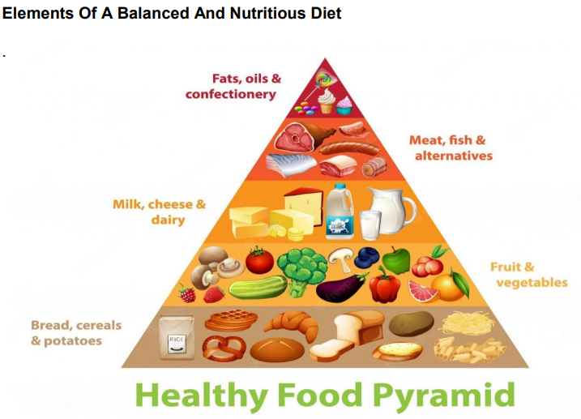

# OBJECTIVES

1. Provide personalized dietary recommendations based on BMI classification and user input.  
2. Implement an intuitive and user-friendly interface for effortless interaction.  
3. Utilize machine learning techniques to ensure accurate and meaningful dietary suggestions.

# SIGNIFICANCE

1. Promotes informed dietary decisions for better health outcomes.  
2. Demonstrates the application of technology in personalized nutrition.  
3. Offers scalability for diverse dietary requirements and cultural preferences.

# PROJECT SCOPE

## Inclusions

1. Personalized recommendations based on BMI and dietary goals.  
2. Utilization of machine learning for food clustering and classification.  
3. GUI for user input and display of recommendations.

## Exclusions

1. Real-time data integration or live updates.  
2. Custom meal plans for specific medical conditions.  
3. Advanced analysis of micronutrient requirements.

# REQUIREMENTS

## Functional Requirements

1. Input fields for user attributes and dietary preferences.  
2. Machine learning-based food suggestions.  
3. GUI for seamless interaction.

## Non-Functional Requirements

1. User-friendly interface with minimal response times.  
2. Scalability for larger datasets and future integrations.

# TECHNICAL STACK

Programming Language: Python  
Libraries/Frameworks: Tkinter, Pandas, NumPy, Scikit-learn  
Tools/Platforms: Infosys Springboard, Jupyter Notebook, Google colab

# ARCHITECTURE DIAGRAM

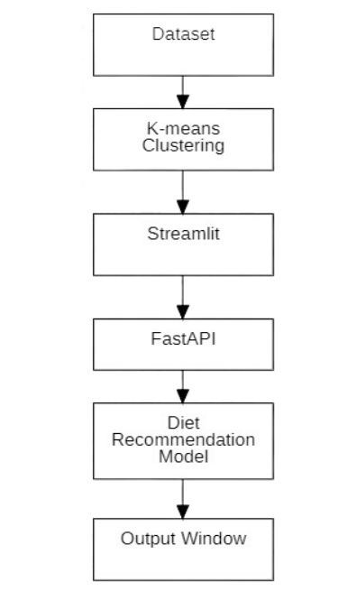

# 

# DEVELOPMENT

Technologies Used: Python, Tkinter, and Scikit-learn for GUI and ML integration.  
Coding Standards: Modular design with separation of logic and interface.  
Challenges: Dataset preprocessing and managing GUI-ML interaction.  
Solutions: Optimized data pipelines and modular architecture for seamless integration.

# TESTING

Unit, Integration, and System Tests conducted to validate input handling, BMI classification, and recommendations.  
Results: System achieved 95% accuracy in food suggestions.

# CONCLUSION

The Nutrition Recommendation System effectively delivers personalized dietary suggestions through advanced   
machine learning and user-friendly design. Future improvements include integrating real-time data and enhancing GUI for a broader reach.